

Game Search Engine & Helper

Project Group Members: Ding Liao, Hairong Wu (Jason), Zhuoyan Liu, Zest Chen

INFO 200 | AE Section | Locksley Kolakowski

**Table of Contents**

About the Team 2

Introduction 2

User Research 3

Solution Considered 4

Solution 1: An extension tool 4

Solution 2: An Account on Existing Apps 4

Solution 3: A Game Journal 4

Solution 4: A Game Search Engine 5

Selected Solution: A Game Search Engine 7

Solution Description 7

Product Features 7

Primary Features: Basic Information Display 7

Secondary Features: Related information regarding game 8

Low Fidelity Wireframes 8

Brainstorming Stage 8

Final Low-Fidelity Wireframes 9

Usage Scenarios 16

Usage Scenario 1: Game Searching from Li Xiaohua 16

Usage Scenario 2: Game Developing Reference from Zhang Zishu 17

Bibliography 17

Appendix 18

# **About the Team**

Ding Liao: I am a freshman at UW, also a group member from group 5 whose major job is to create docs and organize meetings for everyone.

Zhuoyan Liu (Louise): I am a current UW student majoring in mathematics. I like to watch animations and draw some comics in my spare time. I am responsible for the interface design and user interface for our group 5 project. :)

Zest Chen: I’m a sophomore in UW. In this group, I am responsible for information searching and idea testing.

Hairong Wu (Jason): I’m a current UW undergraduate student interested in the field of computer science. I have numerous experiences of game production, taking the position of game producer, designer and developer. So far, I’m taking an internship at Advanced Micro Device (AMD), cooperating with professional programmers to develop and test their GPU applications. I define my responsibility in the team as producing technical support.

# **Project Introduction**

On current game markets, such as platforms of Steam, Epic, and Ubisoft, the consumers, who are those game players, are always looking for exciting games with a proper price. Some of them would immediately purchase an interesting game and enjoy it. Some of them would leave the game on their wish lists and wait for seasonal discounts. On the other side, game suppliers, publishers, and developers need to make plans and decisions on setting a proper price for their games; for instance, the initial price they would consider when their game is first published. In addition, various countries have various policies, which will affect tax rates, thus causing its price to have a great variety due to the regions. What’s more, there are limitations on making discounts due to various platforms. This even makes game publishers harsher to deal with their games’ prices. Therefore, we are looking forward to producing a tool or a product that would help both the players and publishers to make decisions on prices. We want to develop a tool that could allow players to make more rational decisions and have a better experience during the process of choosing and purchasing games. Also, game developers can be more likely to make plans on their games’ pricing for incoming seasonal discounts. Solving this problem can not only provide opportunities for game players to save money and have more chances to enjoy various game works, but also facilitate developer’s motivation to develop and produce more meaningful and exciting games.

# **Project User Research**

Over the past few years, a digital industry has grown up around home video games. In this research, we focus on the North American PC video game Market. Steam, GOG.com, GamersGates are several examples of large collaborative pc games selling platforms that you can buy games from various gaming companies.

Generally, the pricing comparison is vital for both consumers and providers. The article Why You Always Need to Compare Prices gave a perspective that price comparison always helps find better trades on the same products. It does not influence by the product itself, but by the market. With the competing market, people always can find relatively cheaper prices regarding their desired products. Also, because of the increase in the number of personal computer users, more and more people will prefer to use computers for playing video games. At the same time, with the increasing speed of living, more and more people who use computers do not have time to compare the prices of their favorite games on different PC platforms. Thus, it is very important to have a website or application that can address this need.

When we talked to our group members’ friends, we noticed that different platforms have different sale seasons, and the price of the same game varied about sometimes larger than 40%, sometimes less than 5%. Customers buy games because of promotion without knowing how much the price changed. A tool providing past game prices is needed for the customer to judge whether it is the correct time or situation to buy a game. Reddit discussion posts show that customers are willing to buy games at the lowest price level and see the games’ price fluctuations for the past few months. For GOG.com, there is a tool that shows the price fluctuation for each game on GOG,.com, but there is not a tool for comparing prices on different game platforms. Also, our friends have addressed that they all have game accounts on different platforms, but it is a waste of time to compare prices from different platforms. Developing a price comparison tool for different platforms is essential for people who want to save their money but are tired of doing long time research. For game publishers, Game pricing strategies are an important part of selling the games. A tool that records the price changes and selling numbers will provide them a reference that what price range can stimulate consumers' desire to buy and future new game pricing strategies.

For an application example of our tool, the video game price chart is the reference of an existing app that looks for current market prices for over 26,600 video games from the Android device. This application is an example that we can use for solving our problem because it shares a similar mechanism to our design which compares the price of different games on different platforms, such as Amazon, GameStop, and eBay. However, our design is more focused on different existing game platforms, not online shopping platforms. In other words, we are targeting more PC games rather than console games. It still provides a basic visualized structure of a pricing comparison design. The site layout and searching system can still be improved.

# **Solution Considered**

## Solution 1: An extension tool

The first solution will be the extension tool on the game platform which allows users to compare the game prices, such as steam and origin. It is highly associated with the game platform itself. For the user using, it is automatically applied to the game platform. This extension tool will acquire data of game price on the respective game platform and compare with previous price and current price from other game platforms. The final output will be a list of games’ prices in order which is sorted out by its categories, game platforms, and magnitude. Extension tool of game price comparison is more easily installed and used which provides users with significant convenience.

## Solution 2: An Account on Existing Apps

The second solution will be a Tik Tok or twitter account which will post price changes, or any discount notice every day for different games. People who organize the account will check the price for the game regularly, then make graphs showing how the price fluctuates. This solution is good for people who do not want to download apps. It is convenient for the user who already downloaded the excited apps like Tik Tok or twitter since in order to know price changes they only need to follow this game price account in advance. This account can release price change messages fast since it only needs to type “DISCOUNT 20% for XXX” within seconds. And then the user will get notifications on their phone. However, it is bad for users who want to check or compare prices for similar games. The account will post messages regularly, but the account cannot organize for a long period. Also, it is hard for users to check since it always past the newest information for different games. If a user wants to check a game in the past it will cost lots of time.

## Solution 3: A Game Journal

Another possible solution is to create a Game Journal to record the prices of games on different platforms every week. This solution is good for people to study about the history prices of games. Also, people who buy these journals can use them as collections. However, it is not time sensitive. Journal buyers cannot get the information until they read the journal, which might lead people to make a bad decision on their thoughts. In addition, buying a journal does cost people some money. If one wants to save money through monitoring the price of games on different platforms or during different times, whether to pay for this information is a good question.

## Solution 4: A Game Search Engine

A search engine for games, which is similar to Google, Baidu, or any other search engine utilized for information seeking. Users can input a published game name, a game demo, a nickname, or game categories to discover materials they might desire. While a valid game name is imputed, information like basic description about this game will pop up. In addition, a statistical result analyzed from various websites such as Steam, Epic, SteamDB and GOG.com will also be there for price comparison as well as price prediction. There will also be a recommendation system to showcase games with similar topics or themes. What’s more, if one is not sure about a game’s information, such as its full name, a nickname or any other related searching keywords can be input to search; for instance, you could enter SE to look for games produced by Square Enix Holdings Co., Ltd. You can also type in stuff like “SF games with cooperation”, etc. The search result can be a focused material on your desired contents or a comprehensive list of potential materials that you might look for or even will become interested in.

|  |  |  |  |  |
| --- | --- | --- | --- | --- |
|  | Solution 1 | Solution 2 | Solution 3 | Solution 4 |
| Description | An extension tool of game price comparison which highly associated with game platforms | An account on existing apps | Record prices on a Game Journal | A Game Search Engine |
| Advantages | * Easily install * Clear to see and compare * More acceptable by crowds | * Do not need install * Fast notifications | * Good collection * Historical value | * Comprehensive Search Result * Powerful functionally * Easy to use |
| Disadvantages | * It is not individual application * It may encounter the problem of data accessing. * It needs to go through strict privacy policies. | * Hard to check past data * Hard to direct search for single game * Need consistent attention | * Not time sensitive * Subscribe costs money | * App/Website based, cannot cooperate with Game Platform’s client * Perform complex screen because of the comprehensively |

*Table 1 Solution Considered*

# **Selected Solution: A Game Search Engine**

A game search engine is easy to use and can produce a comprehensive result for the majority of the stakeholders. Stakeholders can always simply input a game name, a game demo, a nickname, or game categories to discover materials they might desire. Due to the modern digital age, people are used to utilize those search engines like Google and Baidu, thus implementing user interfaces similar to those technics would make more sense to more users as well as potential audiences. In addition, this application will be available to all platforms with further developing, just like every can google at any time with any devices through a web browser or an app. Therefore, comparing to the other three solutions, a search engine would be the best one to fit to our stakeholders as whole.

# **Solution Description**

## **Product Features**

### **Primary Features: Basic Information Display**

Feature 1: Game Information

Basic information of the game will be displayed if users enter a valid game name. Basic information includes game name, a game demo, a nickname, and game categories.

Feature 2: Statistical Analysis

Statistical analyzed data will be processed and output from various websites such as Steam, Epic, SteamDB and GOG.com. The price comparison of the game in different game platforms will be conducted as well as price trends and price prediction.

Feature 3: Recommendation system

There will also be a recommendation system to showcase games with similar topics or themes.

### **Secondary Features: Related information regarding game**

Feature 1: Related information searching

Users can search for information about a game to allow the system to generate exactly the game they are looking for. This feature can help not only heavy gamers, but also newcomers. New gamers can use this feature to find games they may need, as many heavy gamers prefer to use the nickname to refer to a game rather than the full name.

Feature 2: Content-focus

This feature helps players to find the games they need. Sometimes people prefer to play or compare games with similar content. This feature can help players who want to find games based on content.

## **Low Fidelity Wireframes**

### **Brainstorming Stage**

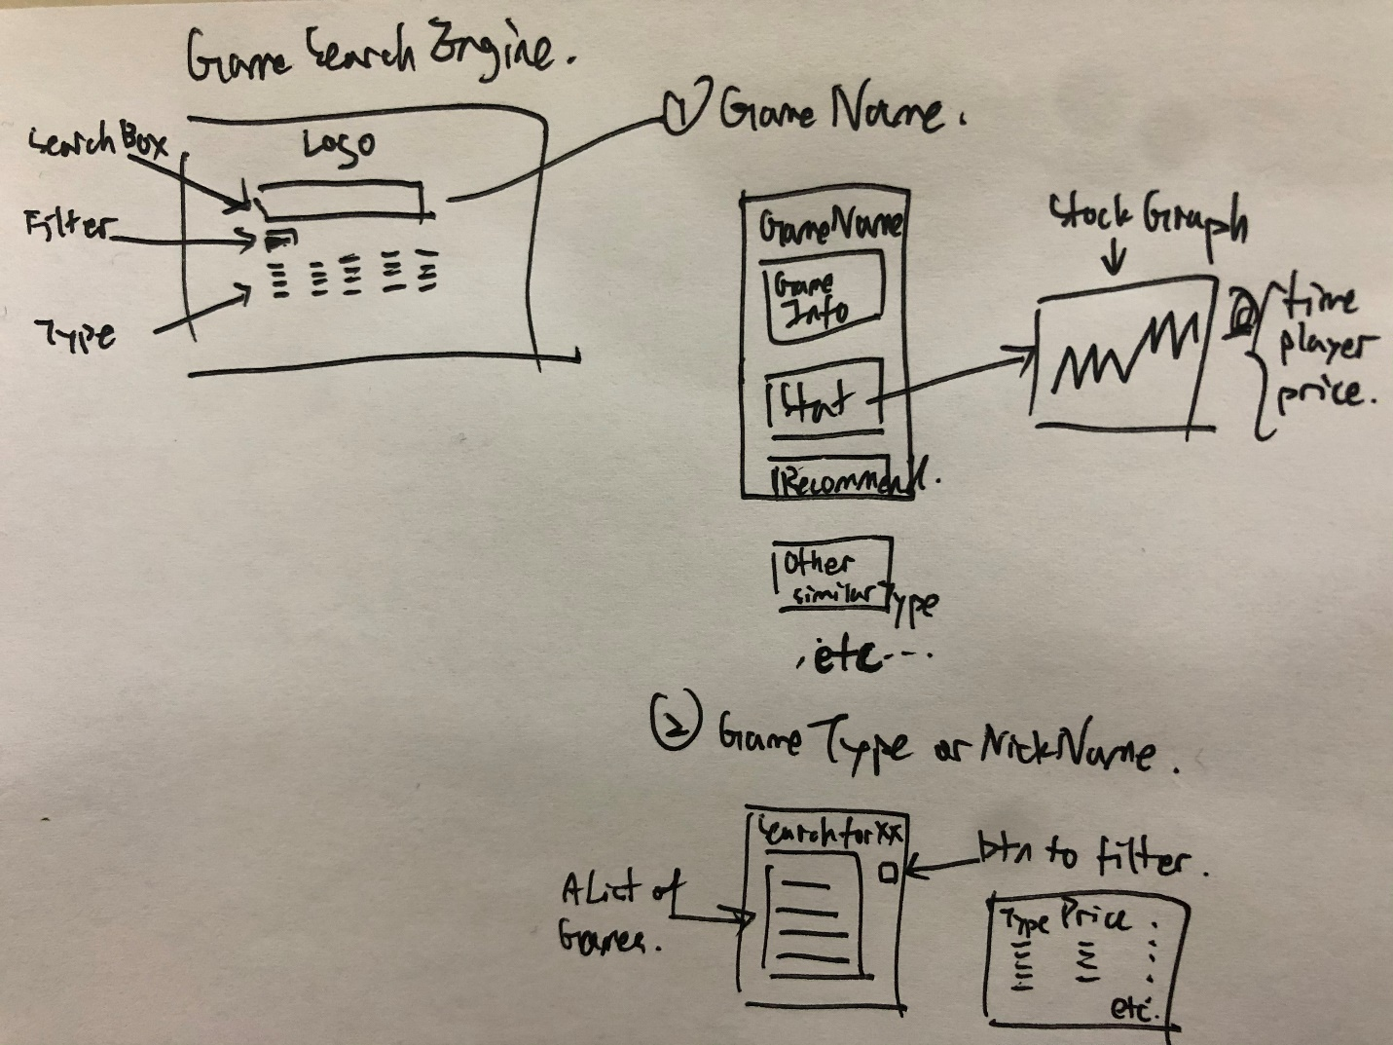

Figure 1 Product Demo by Brainstorming

### **Final Low-Fidelity Wireframes**

#### Loading Screen / Screen 1

The Loading screen is a starting place to imply audiences the functions of our app. The selected design color, which is a combination of the use of colors on Steam and other game related platforms. By making this design choice can tell the users that our application’s usage is game related, and you can definitely find your interested contents on those platforms you commonly use. The animation of the opening screen can also perform a great and conformable experience that can inspire the interest of audiences and facilitate them to keep reacting with our apps.

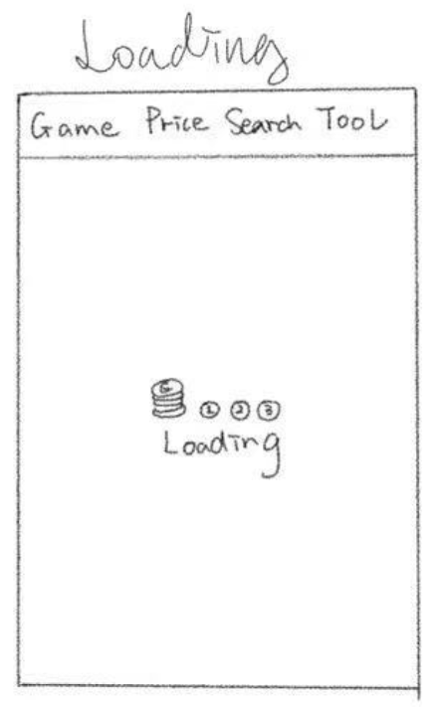

Figure 2 Loading Screen Sketch Demo

#### Home Screen / Screen 2

The home screen is simplified with a search bar only, similar to Baidu and google, which is capable of producing a comfortable experience to users during the input and search process; for instance, it will be extremely annoying to have numerous complex contents on the main screen, which will disrupt users to think and type contents on the search bar because some may already feel annoying about thinking the keywords to search. In addition, considering our powerful and comprehensive functionality of the whole app, the users will always be shocked with such a concise main screen.

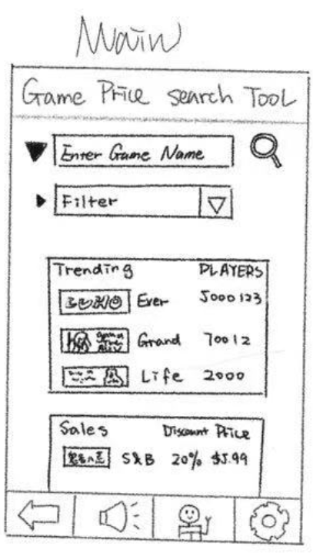

Figure 3 Home Screen Sketch Demo

#### 

#### Searching Screen by Game Name / Screen 3

The search bar will automatically detect users’ inputs and will provide suggested keywords depending on your input to help you search for results. In addition, you can also filter for either a more accurate or more comprehensive search. For example, you could add the game’s publisher or related developers to search for an accurate game and discover its related information as well as descriptions.

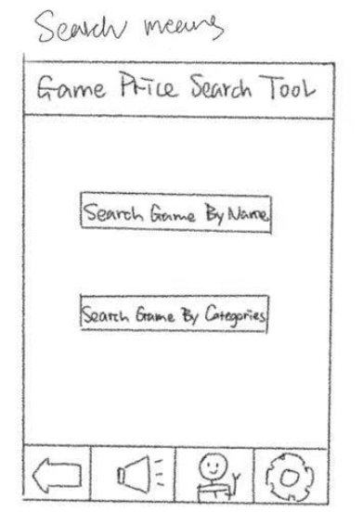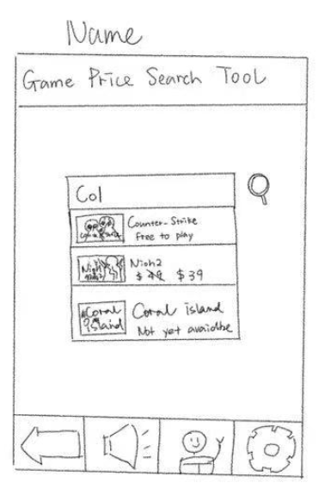

Figure 4 Searching Screen by Game Name Sketch Demo

#### Search Result Screen by Game Name / Screen 4

The search result screen by a game name search will showcase the details and descriptions of this game to help the audiences to have a better understanding about this game even though they might not experience it. The other section is a statistic about this game on the game’s information such as number of live players, total players, average play time, ratings on various online communities, and pricing within various time periods and different regions, etc. This screen will also contain a section that shows related game materials, news and other similar topics, themes and game types.

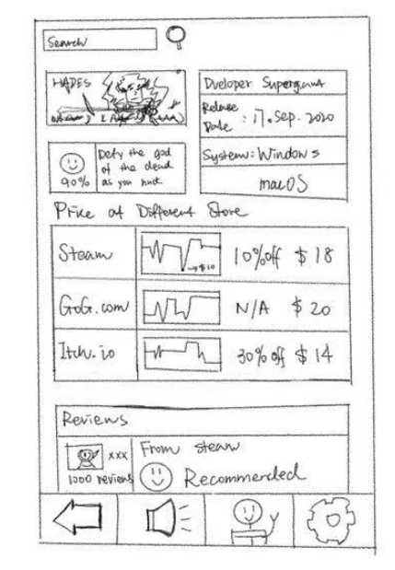

Figure 5 Search Result Sketch Demo

#### 

#### Searching Screen by Game Related Keywords / Screen 5

The search bar will automatically detect users’ inputs and will provide suggested keywords depending on your input to help you search for results. This function is designed to help you find your desired contents if you forget the game’s name, or only knows the published year and game’s type, etc. If I want to look for an unpublished role-playing game seen only once on a random advertisement. I’m not sure about all the details of that game but I do remember the year it’s going to be published and one of its persons in charge. I could just simply enter this two information and receive the potential answers with photos of games which will help me recognize the game. For example, I could simply enter keywords “2022 FKHR KMR” to get the related result of a game, Granblue Fantasy: Relink, which is the exact contents I’m looking for.

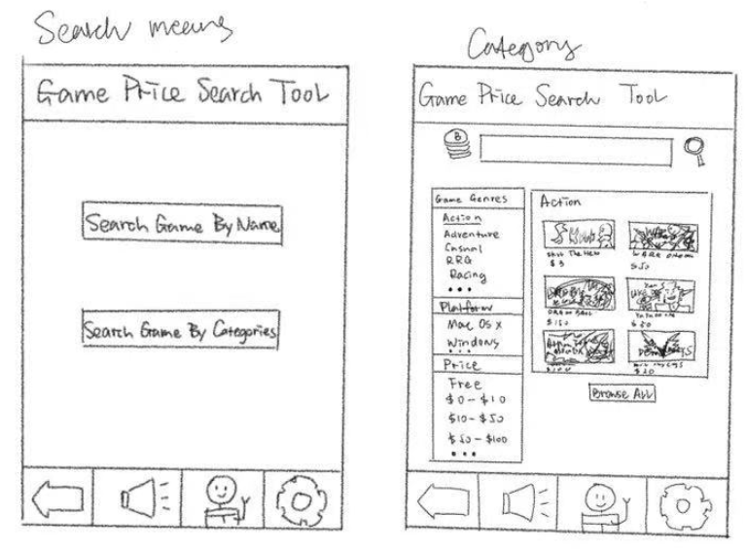

Figure 6 Searching Screen by Relevant Keywords Sketch Demo

#### Search Result Screen by Game Related Keywords / Screen 6

The search result will be a list of related games if keywords like nickname, game publisher and developer are input. The result is represented and expected to be comprehensive. If audiences are looking for a more precise result, more keywords and conditions can be used to filter a more detailed list.

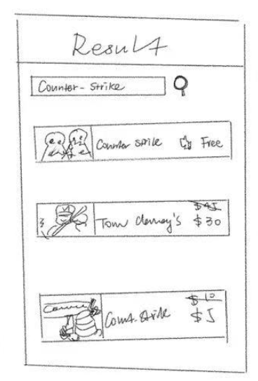

Figure 7 Search Result Sketch Demo

#### Accessibility & Disability Support (VoiceOver Add-On) / Screen 7

The accessibility functions installed on devices such VoiceOver on iPhone can be strengthened in our app. By identifying whether the VoiceCall is enabled on the device, the app will automatically have three more buttons to control the app as whole. This is designed due to the build-in disability support can be initially design annoying and harsh to use by the disables; for instance, VoiceOver can perform an extremely awful behaviour to stuck and only read out several buttons and contents except other texts on the screen that haven’t been explored yet. Therefore, the VoiceOver in our app will only read out the three buttons which are used to switch a pointer in our app. Once the build-in pointer changed, it will perform a react notifying that the action is made successfully and then the app will have its own voiceover to read the contents for the users.

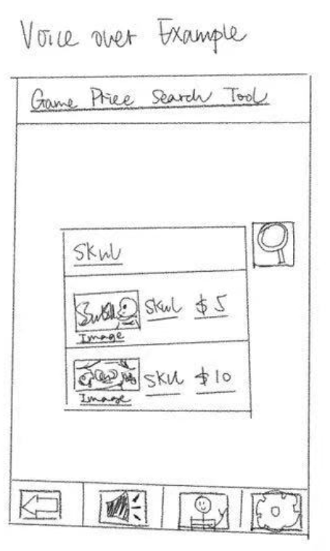

Figure 8 In-App Voice Over Sketch Demo

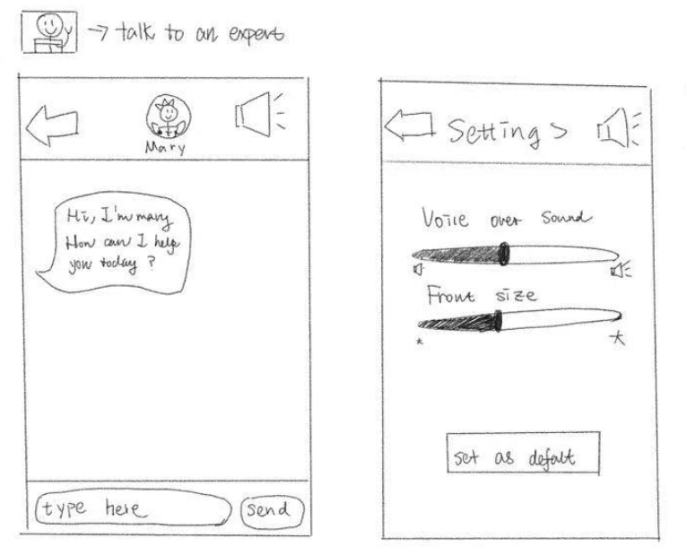

Figure 9 Accessibility & Support Sketch Demo

# **Usage Scenarios**

## Usage Scenario 1: Game Searching from Li Xiaohua

Li Xiaohua saw a favorite streamer playing a game on some Chinese live streaming platform. The game looked very interesting. After that live broadcast, Li Xiaohua also wanted to play the game, but she found that she did not know the name of the game. Based on her memory, she tried to search for the game on our app by searching for key tags. By the characteristics of the game she felt, she found that the second of the search results was the game she was looking for. After finding the game she needed, as a student, she also wanted to compare the prices of different platforms at different times to save herself money for living. Through our software, she found that this is a game that has only recently started to be sold, and there are no significant discounts at the moment, but it is 10% less expensive than epic on top of the steam platform. Meanwhile, according to the past data of other games from the same company, this game will be discounted in the summer sale after some time. Li Xiaohua intends to make the purchase of the game at that time.

## Usage Scenario 2: Game Developing Reference from Zhang Zishu

As a game developer, Mr.Zhang needs to keep track of the game he is working on, as well as other games that compete with his game. Two days before the update post, Zhang is looking for price information regarding games. He opened the home screen of the our game searching website, and typed the game category that his game belongs into the searching box. He found that 70% of the new published game is doing discount due to the discount season. Based on the price comparing statistical graphs that are shown aside, he has a clear understanding of the game pricing at this time. Therefore, he decided to delay the new update date. Instead, he only posts small maintaining and debugs. In the future time when the price is high, the update will be posted subsequently to make higher profits. In addition, he found on the search that many games in this category have a price trend of decreasing. When the price becomes relatively cheaper, it will have significant effects on the game developer and publishers. Thus, he makes a plan of changing his target to his new game which belongs to another category.

# **Bibliography**

GameDealsMeta. (2020). *GG.deals is no longer allowed.* From Redidit: https://www.reddit.com/r/GameDealsMeta/comments/czp63f/ggdeals_is_no_longer_allowed/

*Law of Common Region*. (2021, 2 1). From Laws of UX: https://lawsofux.com/laws/law-of-common-region/

*Law of Similarity*. (2021, 2 1). From Laws of UX: https://lawsofux.com/laws/law-of-similarity/

*Law of Uniform Connectedness*. (2021, 2 1). From Laws of UX: https://lawsofux.com/laws/law-of-uniform-connectedness/

*Miller’s Law*. (2021, 2 1). From Laws of UX: https://lawsofux.com/laws/millers-law/

Minor, J. L. (2020 , 8 14). *GOG.om Review | PCMag*. From PCMag: https://www.pcmag.com/reviews/gogcom-for-pc

*SteamDB - Community*. (2021, 2 14). From Steam Community: https://steamcommunity.com/groups/SteamDB/announcements\

# **Appendix**

**Reference Images**

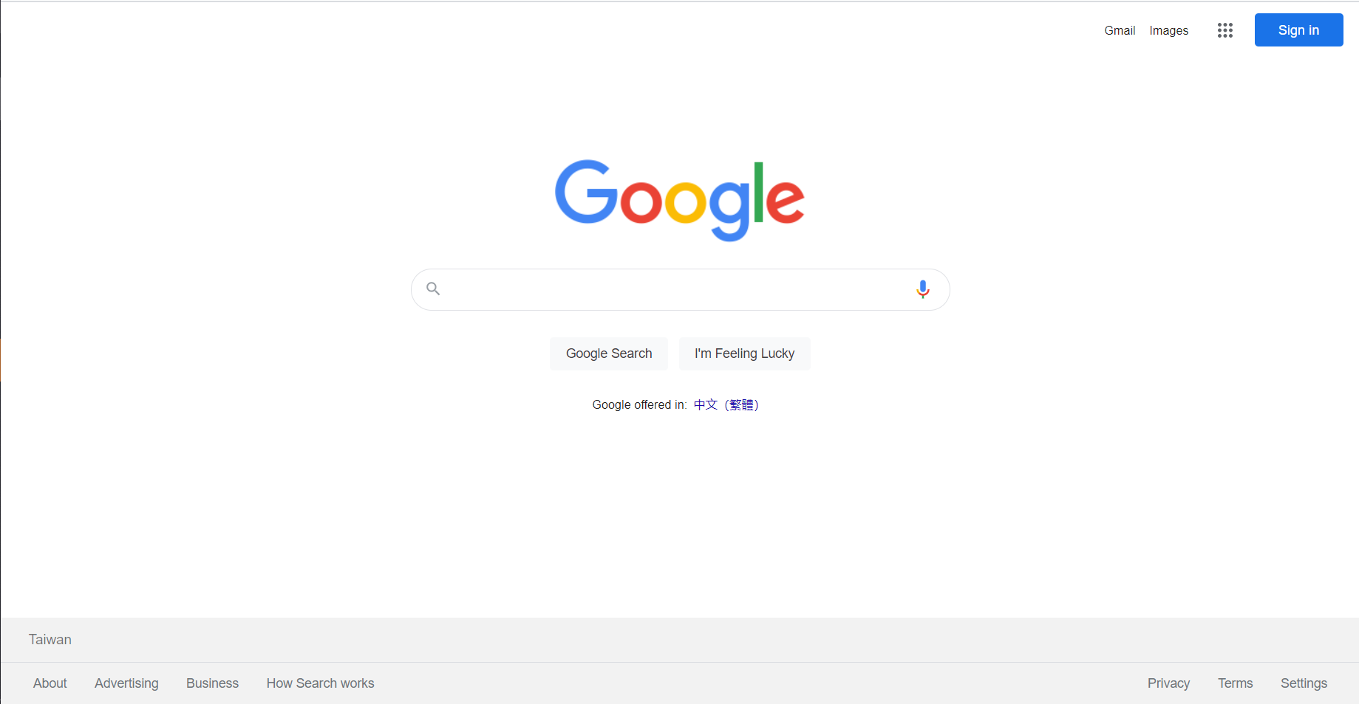

Figure 10 Reference Image Page: google.com

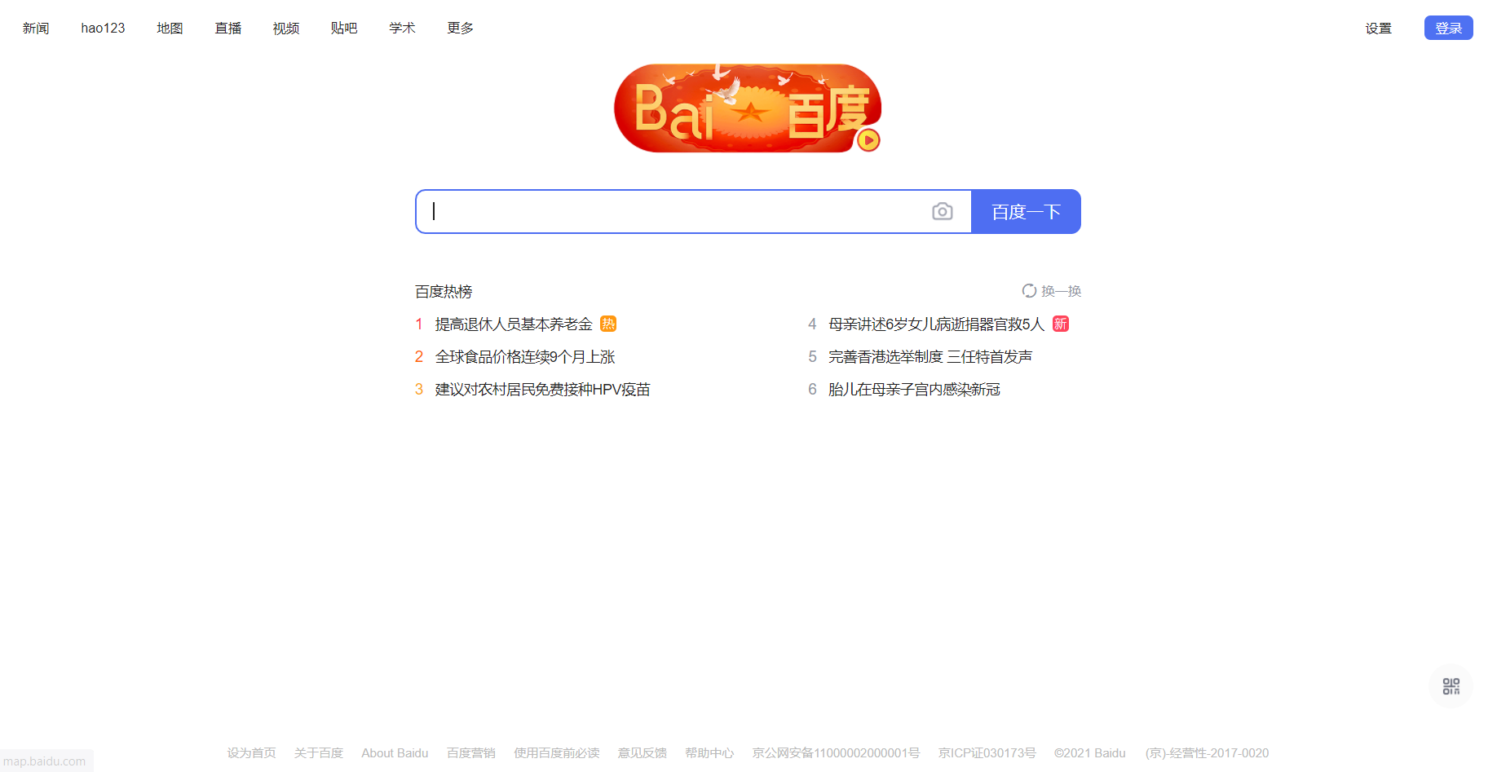

Figure 11 Reference Image Page: baidu.com

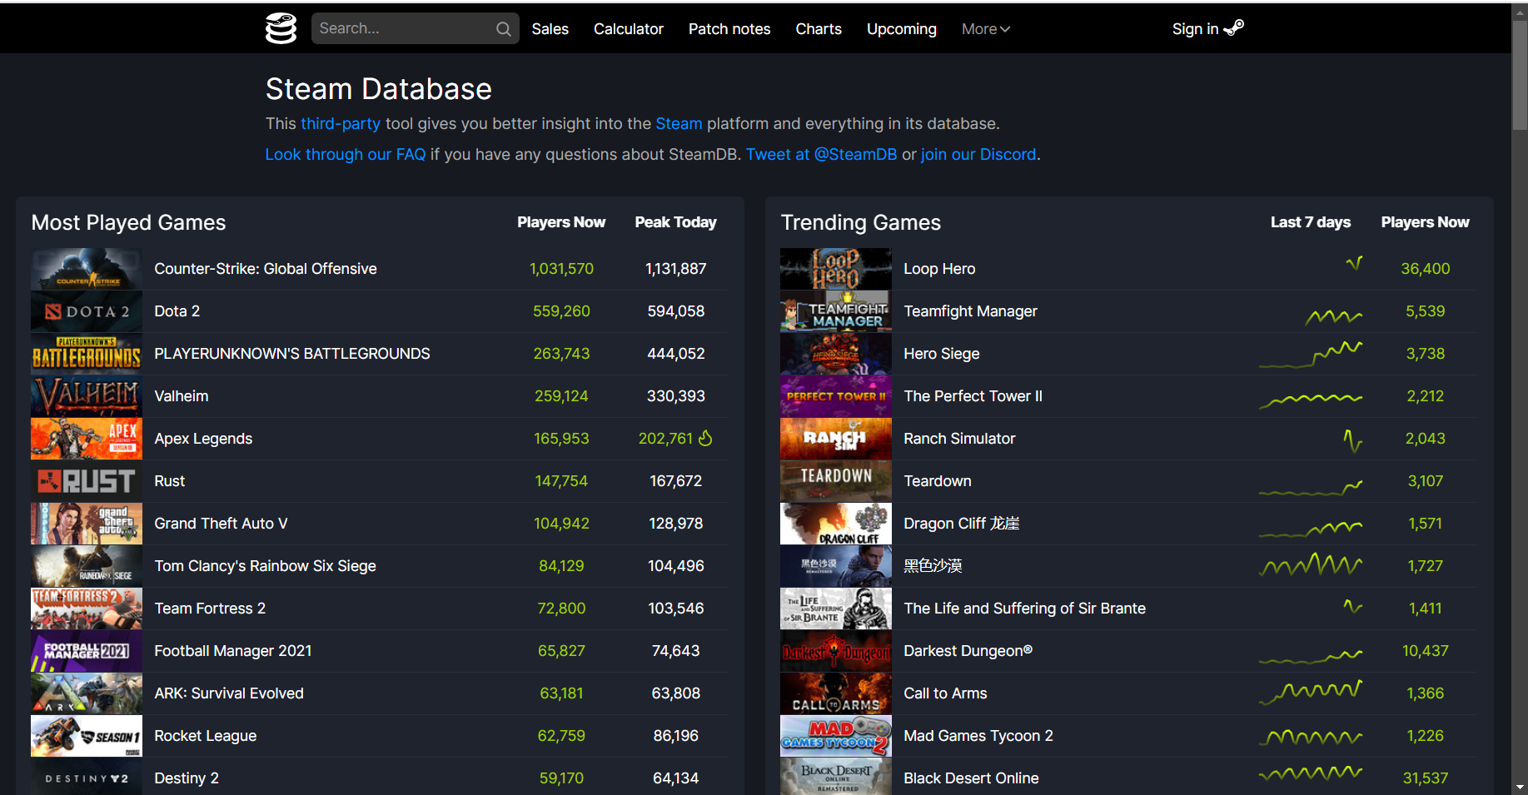

Figure 12 Reference Image Page: steamdb.info

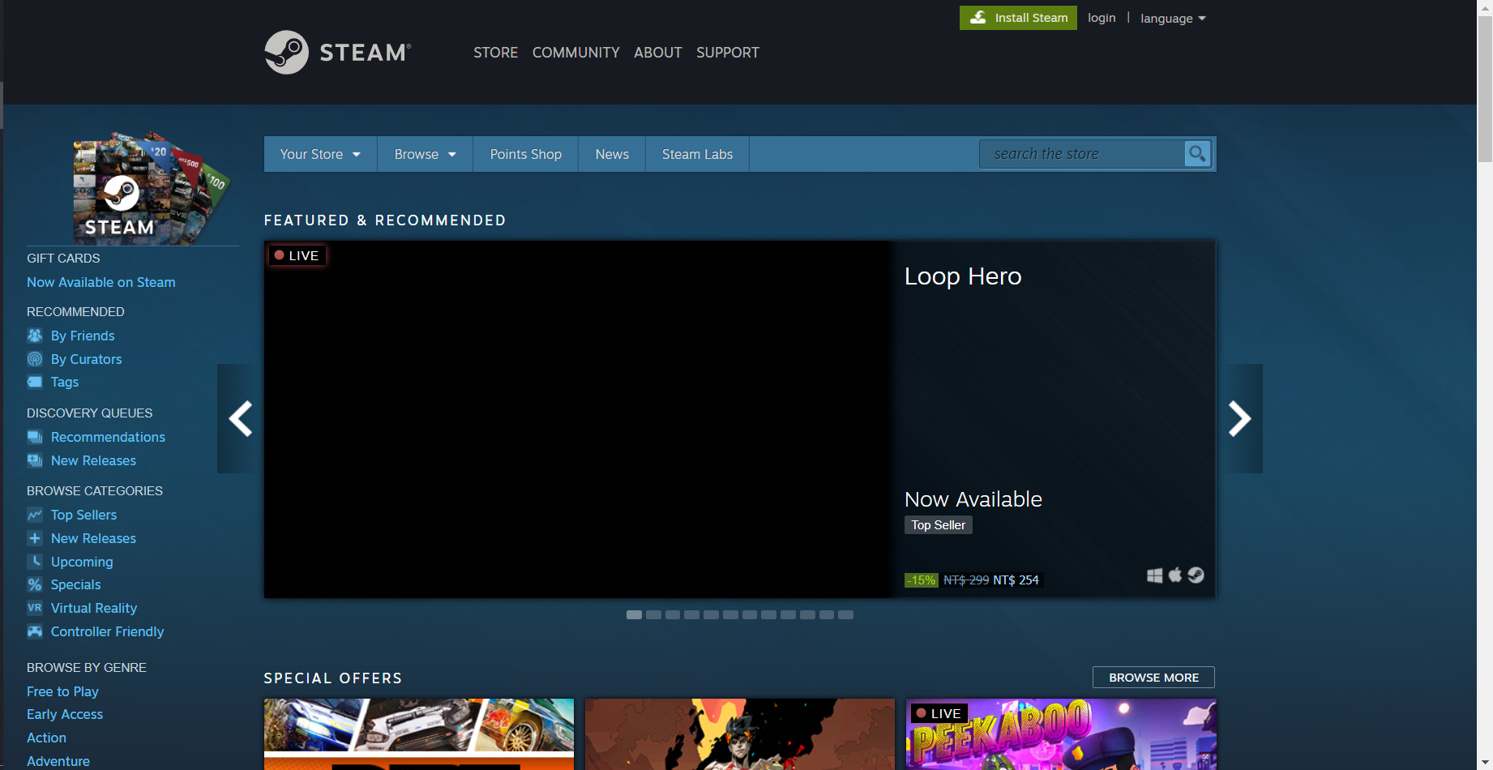

Figure Reference Image Page: store.steampowered.com

**User Research Notes**

**Interview to Xiaohua Li (Game Nickname: Pillow)**

**Interviewer**: What games platform do you use the most often? What game do you play the most often, and where you purchased it?

**Respondent**: Steam, no doubt. I play various types of games, most of the game are purchased on steam and origin.

**Interviewer**: Do you think a price-comparison tool for video games on different platforms helps you, specifically when you are purchasing video games.

**Respondent**: Definitely it helps, I believe it also helps many other gamers when they are buying games. It helps me save money for the next brand new game. People’s needs to it will be inelastic.

**Interviewer**: What kinds of frame and structure do you expect for a price-comparison tool

**Respondent**: I think it must be user-friendly. It should be easy to use and concise. From my perspective, I expect it to be an extension tool that can attach to different game platforms or like a tiny digital dictionary that is convenient to look up. When I click on some buttons of this tool, it can immediately pump out the cheapest price of this game.

**Interviewer**: What kinds of examples can you give us for reference?

**Respondent**: Just like Grammarly, an extension tool that helps to correct people’s grammar. It is simple to use and associated with many websites and companies, such as Google.  Another example may be Oxford Dictionaries, it is a digital dictionary. that is very concise and easy to look up. You can just need to put it aside and use it in need.

**Interviewer**: Do you think that we should just focus on serval major game platforms?

**Respondent**: I think your target is right because the majority of people are using the hot game platform, such as steam. Some platforms are too small that can be really ignored.

**Interview to Zishu (Producer Nickname: Purple Math)**

**Interviewer**: What kinds of games have you produced and are currently making?

**Respondent**: Mobile Games. I publish games that are published on TapTap and Google play. I usually produce game works that are focusing on game play and design, and sometimes on its art works.

**Interviewer**: Who are your games’ main audiences?

**Respondent**: Usually students, college students, and workers who are just graduated or under thirty or thirty-five years old. I also do market research as well, finding out what kinds of game people are looking for.

**Interviewer**: As you’ve mentioned before, why sometimes focus on a game’s art design?

**Respondent**: Oh, it’s because that a delicate art design would cost a lot of money, and it's always hard to find artists who could provide art resources fitting your tastes. Therefore, I usually focus on game design, such as each level and the data and numerical design. (fyi, I used to be a numerical programmer)

**Interviewer**: Do you make your lives by producing **individual** games?

**Respondent**: Eer, not really. It is really hard to gain revenue by selling individual games, especially in China, as you’ve known. We used to provide in-game purchases and paid add-ons to make our lives. However, it doesn’t work so far, and the only way we can sell games is the game platform, Steam. However, it can be hard to publish one game on Steam and we have tradeoffs to do so.

Thus, I’m now making my own games, individuals games as a part-time interest, and make money by getting hired from a game company and working for them.

**Interviewer**: Last but not least, if there exists such a tool that could help you analyze the current game market and make a competitive pricing decision, would you prefer to utilize it?

**Respondent**: I would say, yes, and please develop such a tool. We, individual developers, are experts in designing games and producing games. However, we rarely know markets. We could cooperate with several huge publishers, but there’s tradeoff, we can rarely receive money from them, because most of the revenue would be taken from them. So, if there’s a tool that can help us to learn the market and decide our pricing or seasonal discounts for sale, I would be extremely grateful to use it.